User Manual

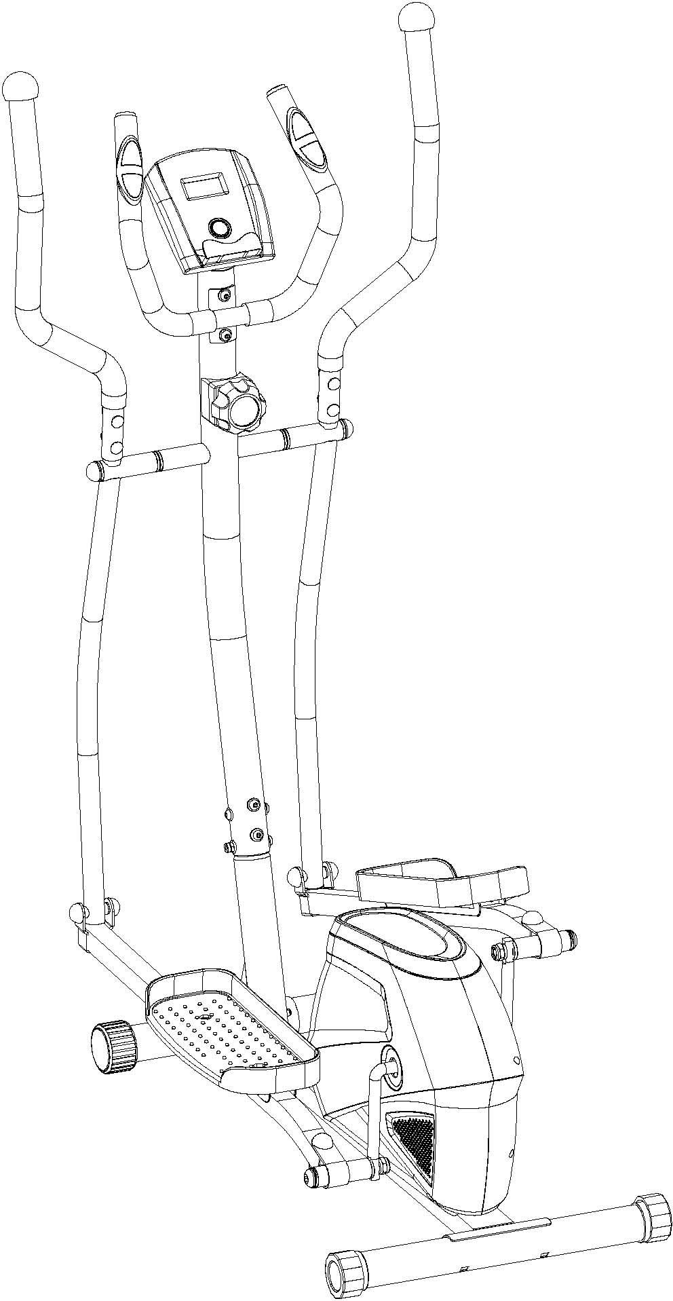

Dear Customer,
Please read this instruction very carefully before using the item.

IMPORTANT SAFETY INFORMATION

Please note the following safety precautions before exercising：
- Read all instructions before assembly & operation；
- Check all screws, nuts & other connections before using the bike；
- Do not expose the equipment to damp places, which will cause failure；
- When assembling, it is best to place parts on a mat (rubber or wood) to avoid soiling；
- Before exercise, make sure that no other items are placed within 2 meters around the equipment；
- Clean only with a damp cloth, do not use solvent cleaners and also note after each exercise should be wiped off the sweat on the equipment；
- Incorrect or excessive exercise can damage your health. It is recommended to consult a doctor before exercising. He will give you a maximum amount of training (including pulse, watts, duration, etc.) so that you can Exercise and get accurate information. Note：This equipment is not suitable for therapeutic use；
- only when the machine is in normal conditions to exercise, maintenance can only use the original accessories provide by the factory；
- This machine can only be used by one person at a time;
- Always wear sport clothes and sports shoes when exercising,especially the sports shoes must fit.
- If at any time during exercise you feel faint, dizzy or experience pain, stop and consult your physician.
- Children and disabled persons can only use when they are under guardianship;
- The design of this car can adjust the size of the resistance to adjust the motion intensity, and can be adjusted back and forth between light and heavy to select your suitable resistance.
- The maximum weight capacity of this unit is 100 kilograms.
- This equipment is designed for indoor use only!

Attention: Make sure all screws and nuts are tightened before Exercise
Tip: The front end cap can be moved,it allows you to move the bike.

Exploding Picture and Part Lists

EXPLODED DRADWING 1：

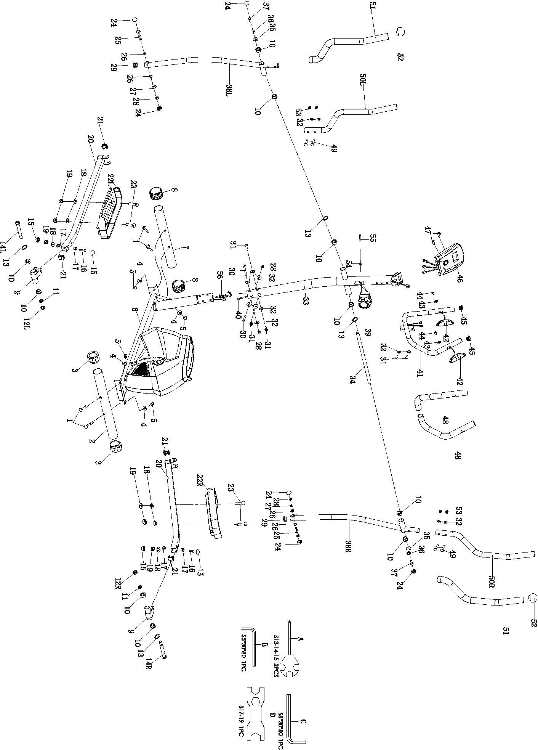

HARDWARE PACKAGE No.1 ：

No. | Description | Qty | No. | Description | Qty
1 | Square Bolt M10*56 | 4 | 33 | Upright Support | 1
2 | Rear Stabilizer | 1 | 34 | Long Axle Φ15.8*405 | 1
3 | Rear Stabilizer End Cap | 2 | 35 | Flat Washer Φ8*Φ28*2.0 | 2
4 | Arced Washer Φ20*Φ10.5*2 | 4 | 36 | Spring Washer Ring D8 | 2
5 | Domed Nut M10 S17 | 4 | 37 | External Hexagon Bolt M8*20 S14 | 2
6 | Main Frame | 1 | 38L/R | Swing Pole(L/R) | 2
7 | Front Stabilizer | 1 | 39 | Resistance Controller | 1
8 | Front Stabilizer End Cap | 2 | 40 | Monitor Mid Wire | 1
9 | Pole Conjunction | 2 | 41 | Mid Handlebar | 1
10 | Nylon Axle Sleeve Φ28*Φ24*Φ16 | 10 | 42 | Pulse | 2
11 | Spring Washer Ring D13 | 2 | 43 | Washer D5 | 2
12L | Nylon Nut(L) 1/2"×20- 左 S19 | 1 | 44 | Crossed Pan Self-tapping Screw ST4.2*20 | 8
12R | Nylon Nut(R) 1/2"×20 S19 | 1 | 45 | Round Tube Cap Φ25*1.5 | 2
13 | Waved Washer Ring Φ26*Φ16*0.3 | 4 | 46 | Monitor | 1
14L | Pedal Bolt φ16×89×1/2"×20-L S8 | 1 | 47 | Crossed Pan Screw M5*10 | 2
14R | Pedal Bolt φ16×89×1/2"×20-R S8 | 1 | 48 | Mid Handlebar Foam | 2
15 | Ball Nut Cover S16 | 4 | 49 | Square Bolt M8*40 | 4
16 | External Hexagon Bolt M10*55 S17 | 2 | 50L/R | Handlebar | 2
17 | Small Axle Sleeve Φ18*Φ14*Φ10.2*13 | 4 | 51 | Handlebar Foam | 2
18 | Flat Washer Φ10.5*Φ20*1.5 | 6 | 52 | Tube Cap | 2
19 | Nylon Nut M10 S17 | 7 | 53 | Domed Nut M8 S13 | 4
20L/R | Pedal Pole Tube | 2 | 54 | Arced Washer D5 | 1
21 | Square Tube Cap | 4 | 55 | Crossed Pan Screw M5*40 | 1
22L/R | Pedal | 2 | 56 | Resistance Controller Down Wire | 1
23 | Small head Hexagon Bolt M10*45 S14 | 4 | A | Wrench S13-14-15 | 2
24 | Ball Nut Cover S13 | 6 | B | Wrench S5*30*80 | 1
25 | External Hexagon Bolt M8*55 S14 | 2 | C | Wrench S8*30*80 | 1
26 | Small Axle Sleeve Φ16*Φ12*Φ8.2*9.5 | 4 | D | Wrench S17-19 | 1
27 | Flat Washer D8*Φ16*1.5 | 3
28 | Nylon Nut M8 S13 | 5
29 | Round Tube Cap Φ28*1.5 | 2
30 | Inner Hexagon Pan Bolt M8*60 S5 | 2
31 | Inner Hexagon Pan Bolt M8*15 S5 | 5
32 | Arced Washer Φ8*Φ16*1.5 | 13

EXPLODED DRADWING 2：

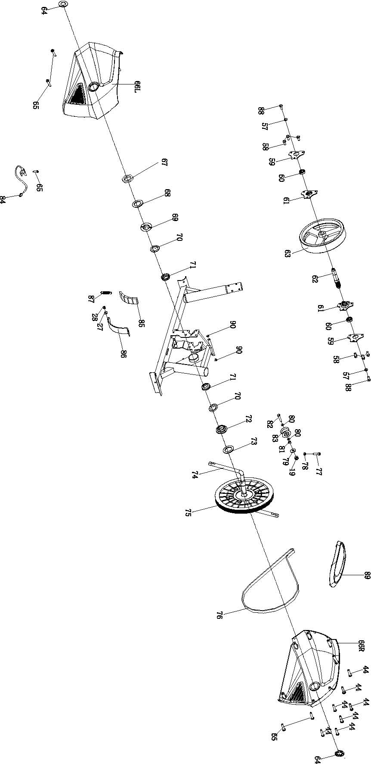

HARDWARE PACKAGE No.2 :

57 | Flat Washer Φ6.5*Φ16*1.5 | 2 | 76 | Belt
58 | External Hexagon Bolt M6*9 | 6 | 77 | Inner Hexagon Cylinder Bolt M6*25 | 1
59 | Bearing Board | 2 | 78 | Hexagon Nut M6 S10 | 1
60 | Bearing 6001RS | 2 | 79 | Flat Washer D10*Φ20*2 | 1
61 | Bearing Support | 2 | 80 | Flat Washer Φ10.2*Φ14*1 | 2
62 | Flywheel Axle | 1 | 81 | Idler Wheel Spacer | 1
63 | Flywheel | 1 | 82 | Small head Hexagon Bolt M10*40 S14 | 1
64 | Crank Cap | 2 | 83 | Arced Idler Wheel | 1
65 | Crossed Pan Self-tapping Self-drilling Screw S4.2*16 | 5 | 84 | Sensor | 1
66L/R | Chain Cover | 2 | 85 | Black Magnetic | 5
67 | Hexagon Nut | 1 | 86 | Magnetic Board | 1
68 | Anti-loosen Washer | 1 | 87 | Spring | 1
69 | Double Groove Nut | 1 | 88 | External Hexagon Bolt M6*15 S10 | 2
70 | Ball Rack | 2 | 89 | Up Chain Cover | 1
71 | Bead Bowl | 2 | 90 | Tube Cap | 2
72 | Tri-groove Nut | 1
73 | Washer | 1
74 | Crank | 1
75 | Belt Disk | 1

Assembly Instructions
1.Preparatory work:
A. Make sure there is enough space before installation；
B. Confirm all of the components are all-ready before installation. ( refer to previous product exploded view which indicates the name and the location of the components)；
C. Use the provided tools or the special self-contained tools to install。

2. Assembly instructions:
Step 1:
Lock Front Stabilizer（7）and Rear Stabilizer（8）into Main Frame（6）respectively by using Square Bolt（1）,Arced Washer（4）and Domed Nut（5）.

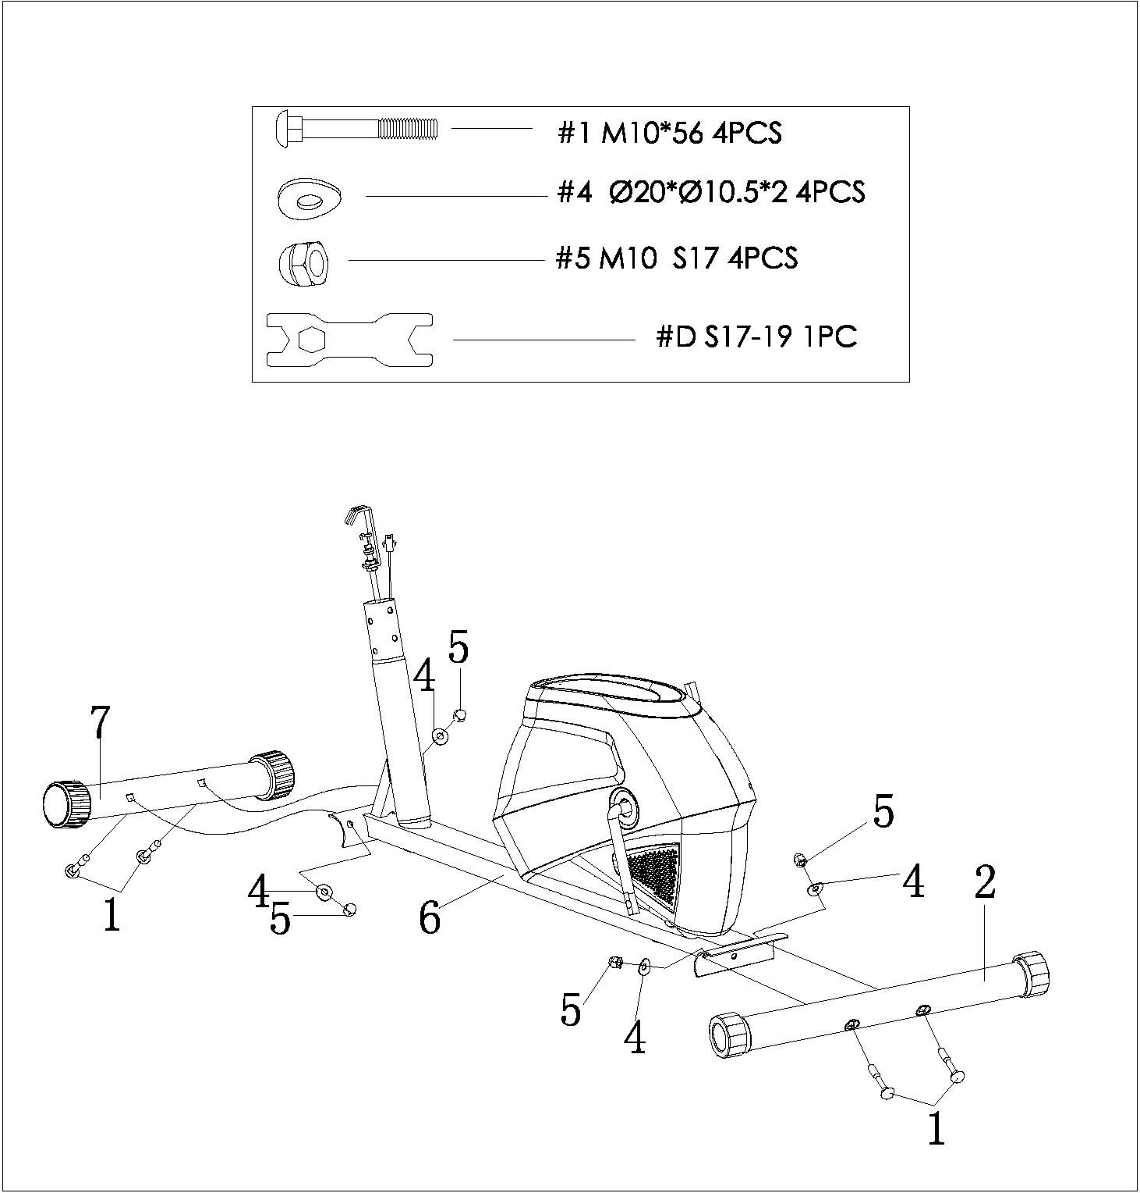

Step 2：
First,lock Resistance Controller（39）into Upright Support（33）by using Crossed Pan Screw（55） and Arced Washer（54）.
Second,connect Monitor Mid Wire（40）and the wire of Sensor（84）.Then ,connect the wire of Resistance Controller（39）and Resistance Controller Down Wire（56）.
Third,lock Upright Support（33）into Main Frame（6）by using Inner Hexagon Pan Bolt（31）、Inner Hexagon Pan Bolt（30）、Arced Washer（32） and Nylon Nut（28）.
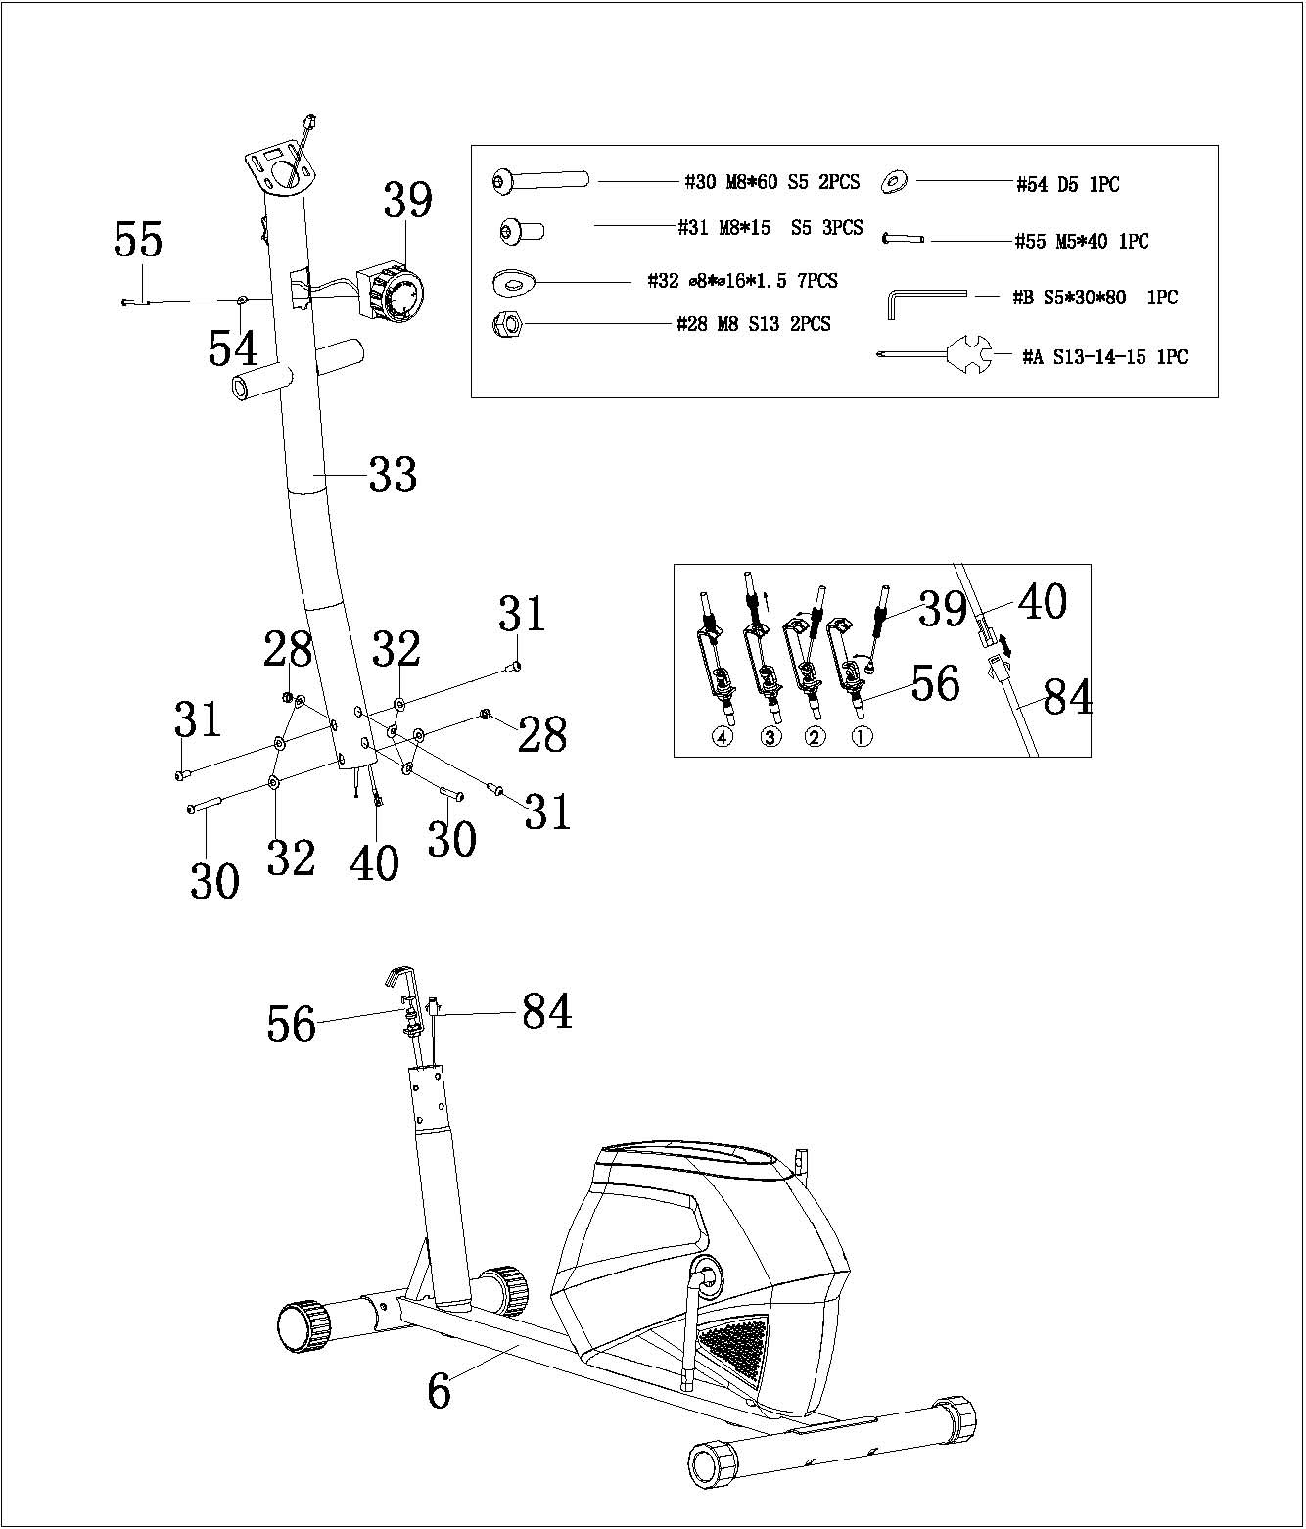

Step 3：
First,pull out External Hexagon Bolt（37）、Spring Washer Ring（36）、Flat Washer（35） and Waved Washer Ring（13）from Long Axle（34）.
Second,make Long Axle（34）through Upright Support（34）and install Waved Washer Ring（13）into lock Long Axle（34）.
Third,insert Swing Pole（38L/R）into Long Axle（34）respectively and lock Swing Pole（38L/R）in Long Axle（34）by using External Hexagon Bolt（37）、Spring Washer Ring（36）and Flat Washer（35） ,then install Ball Nut Cover（24）.
Finally,lock Pedal Pole Tube（20L/R） into Crank（74）respectively by using Pedal Bolt（14L/R）、Waved Washer Ring（13）、Spring Washer Ring（11）and Nylon Nut（12L/R） ，then insert Ball Nut Cover（15）.

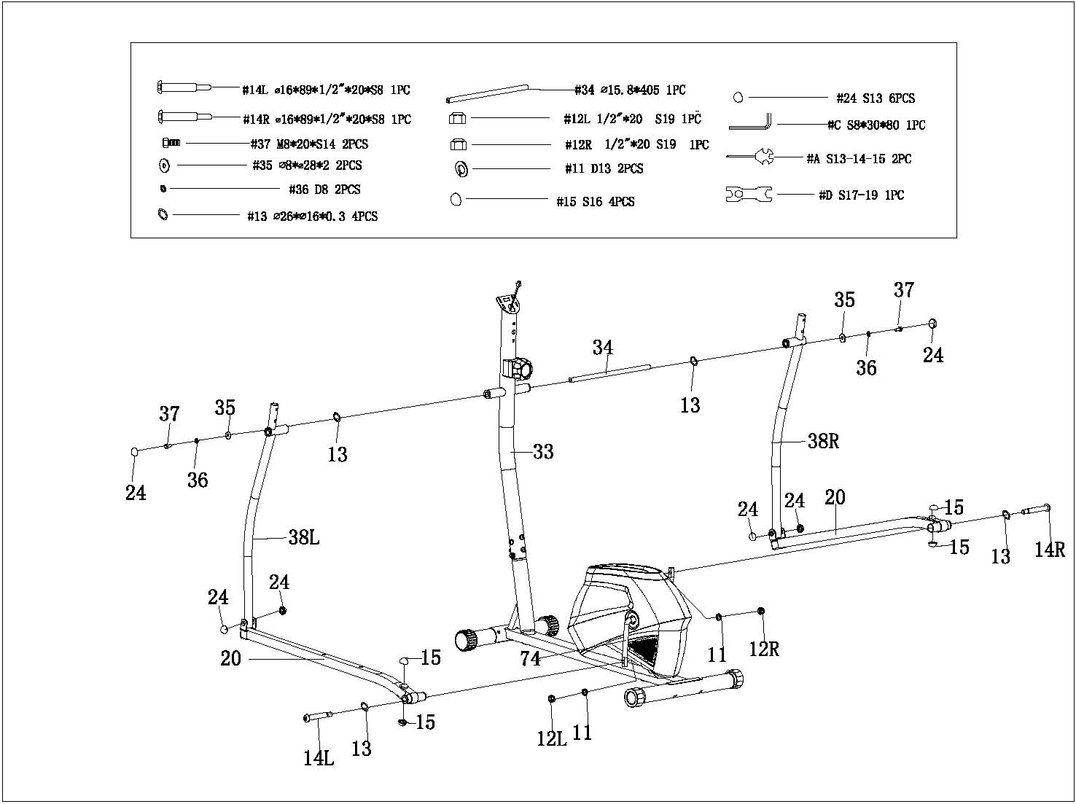
Note：
It should be toward clockwise when lock Pedal Bolt（14R），while toward anti-clockwise when lock Pedal Bolt（14L）.

Step 4：
Lock Pedal（22L/R）into Pedal Pole Tube（20L/R）respectively by using Small head Hexagon Bolt （23）、Flat Washer（18）and Nylon Nut（19）.

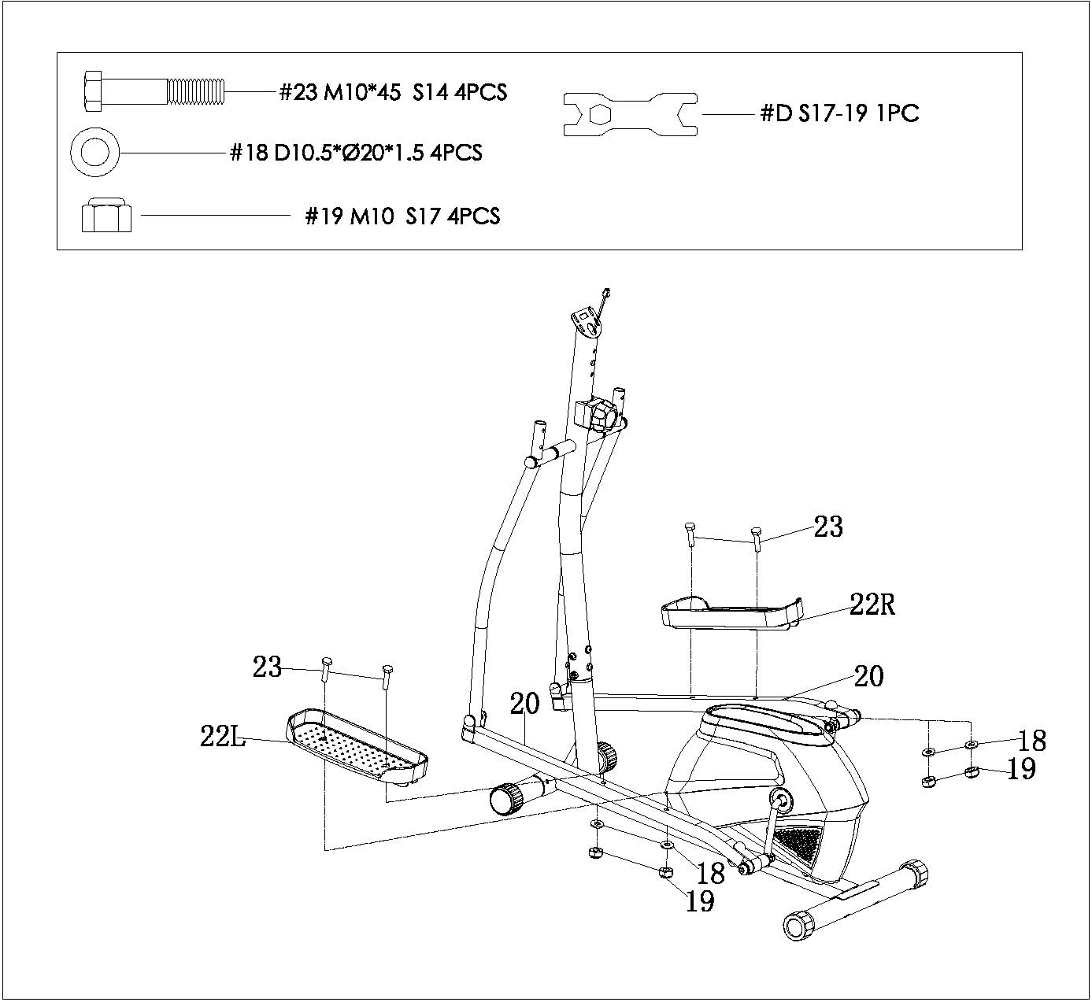

Step 5：
First,make wire of Pulse（42）through the wire hole of Upright Support（33）and drag it out from the top of Upright Support（33）.
Second,lock Mid Handlebar（41）into Upright Support（33）by using Inner Hexagon Bolt（31）and Arced Washer（32）.
Third，pull out Crossed Pan Screw（47）from Monitor（46）. Then,connect the wire of Monitor（46）with Monitor Mid Wire（40）and the wire of Pulse（42）.
Finally,lock Monitor（46）into Upright Support（33）by using Crossed Pan Screw（47）.
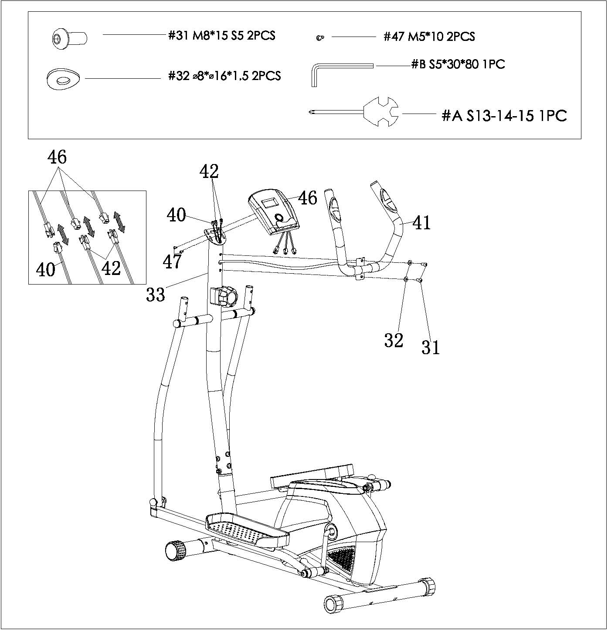

Step 6：
First,insert Handlebar （50L/R）into Swing Pole（38L/R）respectively .
Second,keep holes of Handlebar（50L/R）inline with holes of Swing Pole（38L/R）respectively and lock them together by using Square Bolt（49）、Arced Washer（32）and Domed Nut（53）.

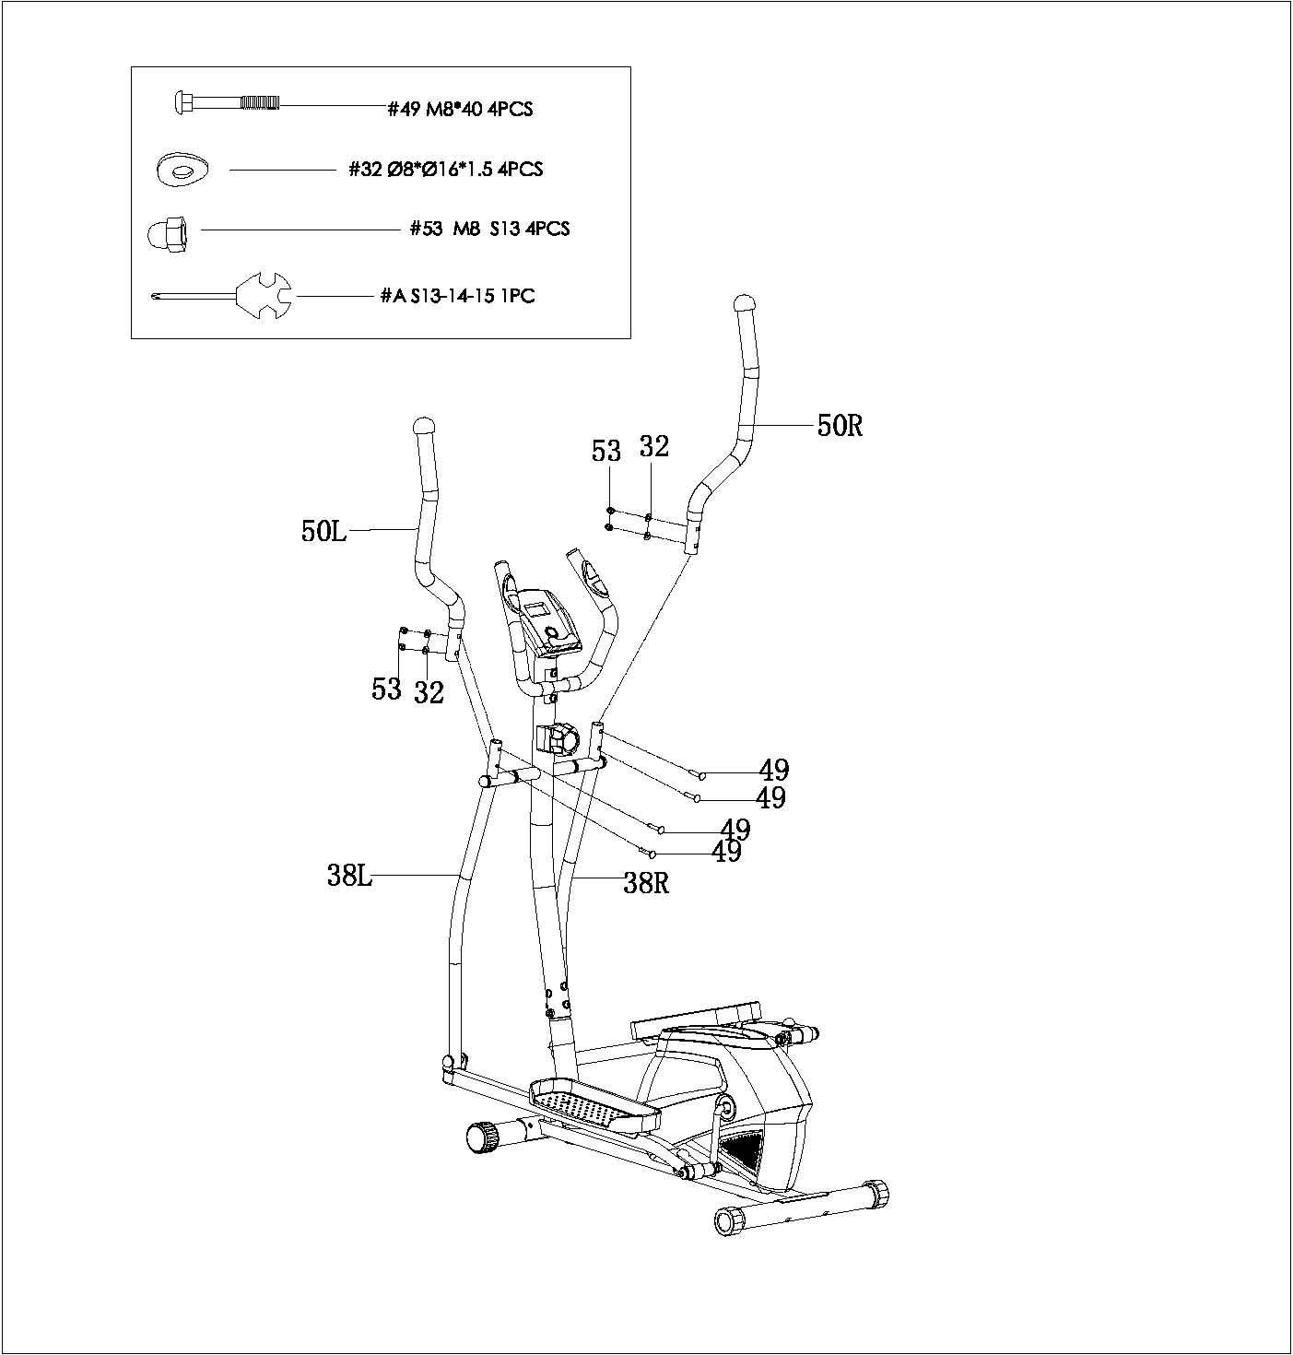

EXERCISE INSTRUCTIONS

The Warm Up Phase
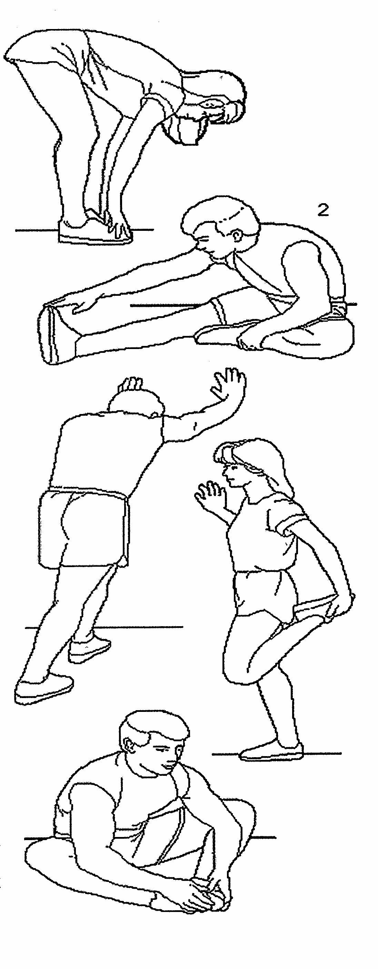
This stage helps get the blood flowing around the body and the muscles working properly. It will also reduce the risk of cramp and muscle injury. It is advisable to do a few stretching exercises as shown below. Each stretch should be held for approximately 30 seconds, do not force or jerk your muscles into a stretch - if it hurts, STOP.
1、Down Stretch
Bend your knees slightly and body slowly, let your back and shoulders relax, and try to touch your toes.Keep it for 10 ~15 seconds,repeat 3 times.
2、Hamstring Stretch
Sitting on a clean cushion,then bend your right foot.Place your left foot against the inner thigh of your right foot. Try to touch your toes 。Keep it for 10 ~15 seconds,repeat each foot 3 times .
3、Calf and Foot Stretching
Stand and place both hands on a wall or a tree,one foot behind.Keep the behind foot stand and it’s heel on the floor,then tilt to the wall or tree.Keep it for 10 ~15 seconds,repeat each foot 3 times
4、Quadriceps Stretch
Place your left hands against a wall or a desk to aid your balance.Then grasp your ankle with your left hand and pull your foot toward your buttocks. Keep it for 10 ~15 seconds,repeat each foot 3 times .
5、Groin Stretch
Sit with your knees flexed and soles of feet together.Hold your ankles and bend at your hips.Keep it for 10 ~15 seconds,repeat 3 times.
Exercise Stage
This stage should last for a minimum of 12 minutes though most people start at about 15~20 minutes. After repeat it easily for several times,you can increase training strength.After exercising for a period of time,your heart beat will be close to the best position in the graph as below (Shaded part).Note: This exercising is for your whole life,it can not complete in one night,so you should keep it .

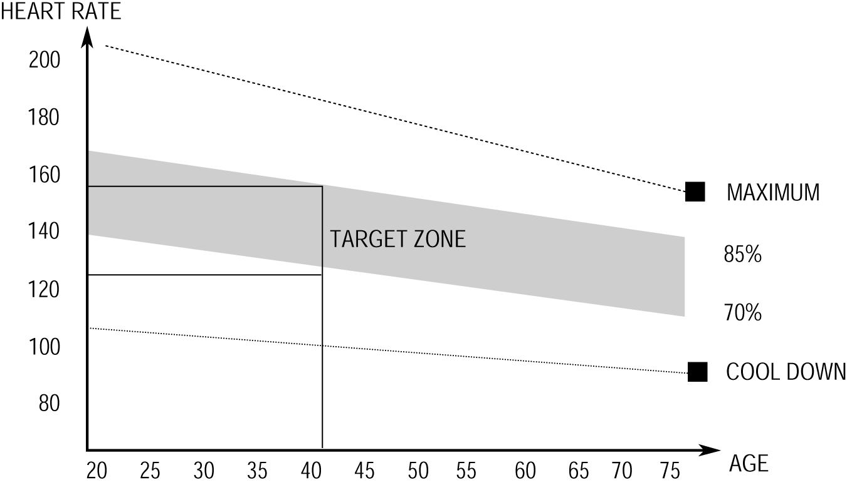

Recovery Phase
This stage is to let your Cardio-vascular System and muscles wind down. This is a repeat of the warm up exercise e.g. reduce your tempo, continue for approximately 5 minutes. Then repeat the exercise phase,please be careful not to force or jerk your muscles.
When using elliptical fitness exercises, please don't increase training intensity arbitrarily. It may make your leg muscles sprain, which means you can't continue exercising for a long time.
Equipment Tip
Adjusting the Tension Control can change the resistance of the equipment,the high resistance the harder to step. Users can use this device to find a suit

